In Workday, you can view your grades at any time during the academic period. There are two kinds of grades - interim grades, and final grades.
Interim grades are updated as you move through the academic period. Interim grades are helpful for assessing your progress. Final grades are assigned at the end of academic period and are recorded in your academic record.

Use this reference to view your interim grades.

INSTRUCTIONS
- Log into Workday and enter the Academics app.

- Click the “Academic Profile” tab.

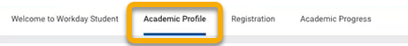

- In the right-hand toolbar, click “View My Interim Grades”.

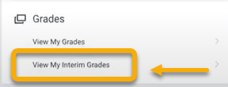

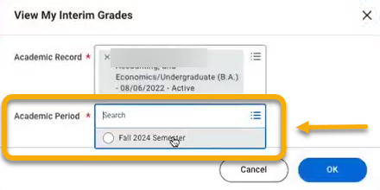
- In the View My Interim Grades window, there will be two fields. The Academic Record field will auto-populate with your information. In the Academic Period field, you must select the desired academic period. Click the field and make a selection.

- Click “OK”.



